**Registering the OneDrive Restore Application in your Azure Organization**

In order for the OneDrive Restore Utility to work, An Azure Application Registration needs to be created in the Org

1. From the Azure Portal, select “App Registrations” and click “New registration”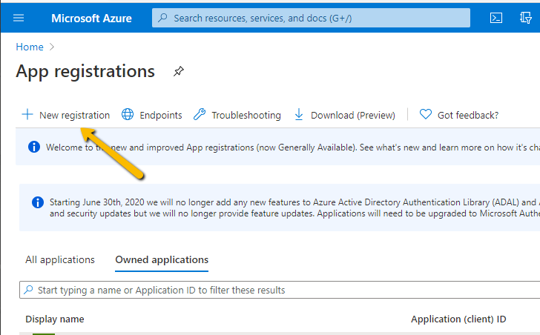
2. When prompted, fill Out the information below regarding the app
   1. Set the Supported Account types to “Single Tenant”
   2. Set the Redirect URI for “Web”
   3. Set it to “http://localhost:5000/auth-callback

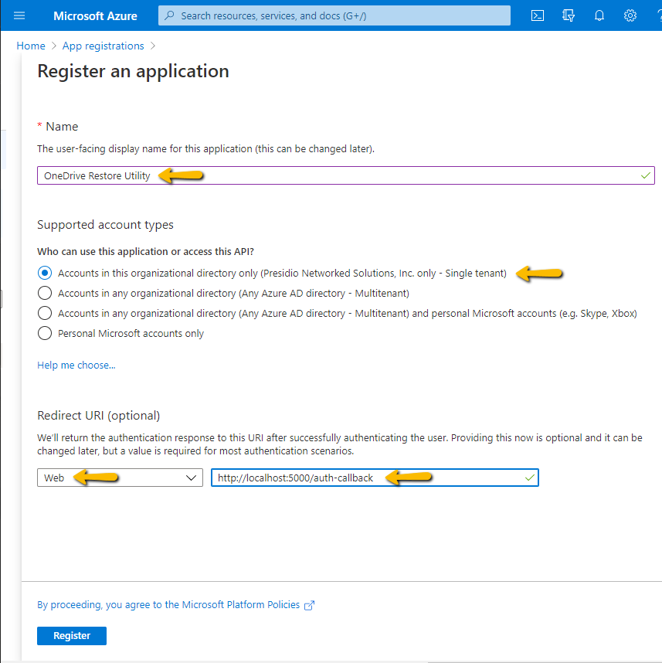

1. Click “Register” 
2. Collect the following fields from your app registration 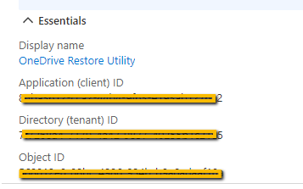
3. Generate a “Client secret” for the application and keep it handy (will be required for the application config file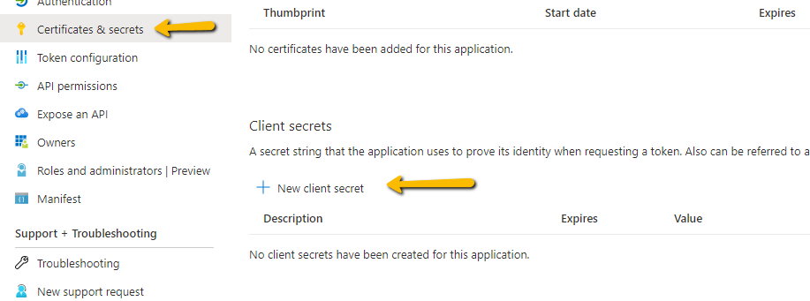
4. Under API permissions, click “Add a Permission” 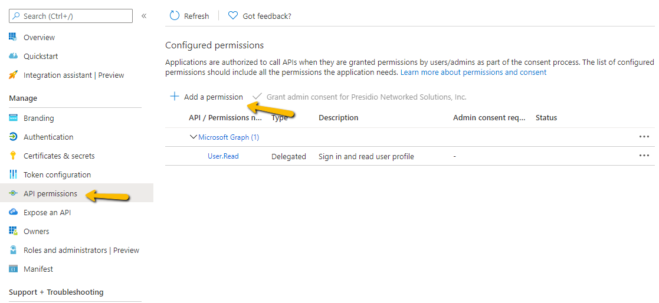
5. Select GraphAPI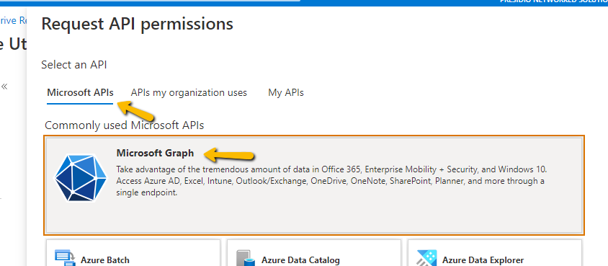
6. Because the OneDrive Restore utility works on the end user’s behalf, we need to select “Delegated permissions” (The app will work based on the authenticated user) 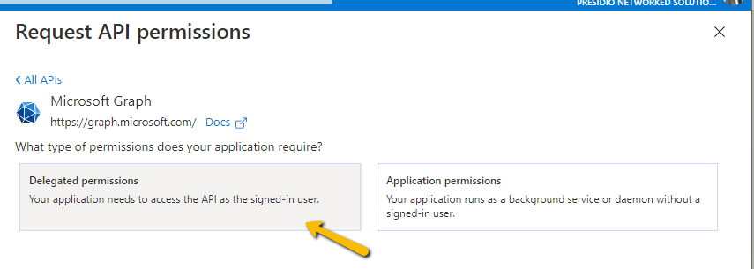
7. Search for “files” and select “Files.ReadWrite” 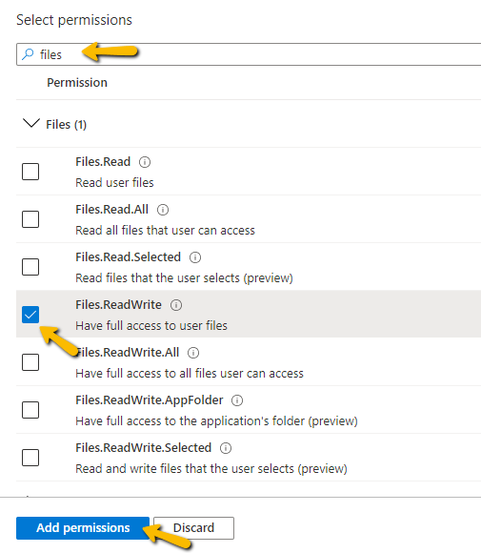
8. Congratulations, the app registration is now complete.

**Application Registration Notes:**

|  |  |
| --- | --- |
| Field | Value |
| Application (client) ID |  |
| Directory (tenant) ID |  |
| Object ID |  |
| Client Secret |  |
| Web Auth Callback URI | http://localhost:5000/auth-callback |